ISearch Guided Notes
Use these guided notes for the following lessons in the ISearch for Teachers class.
- Getting to Know ISearch
- ISearch Basics
- Searching Across the Tabs
- Getting the Results You Want
Getting to Know ISearch
- Label the main components of the ISearch landing page:
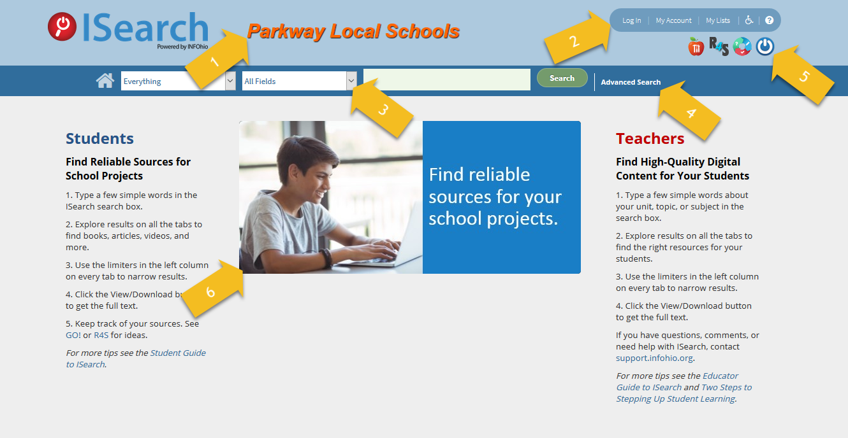

1. ________________________________ 2. ________________________________
3. ________________________________ 4. ________________________________
5. ________________________________ 6. ________________________________

- Label the main components of the ISearch My Library tab results screen.
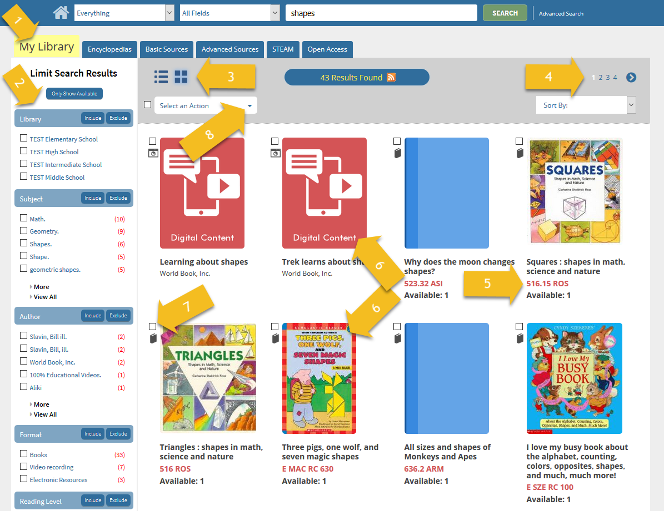

1. ________________________________ 2. ________________________________
3. ________________________________ 4. ________________________________
5. ________________________________ 6. ________________________________
7. ________________________________ 8. ________________________________

- Briefly describe the kinds of results you’ll find under each of the tabs in ISearch.
My Library:
Encyclopedias:
Basic Sources:
Advanced Sources:
STEAM:
Open Access:
Search Basics
- The narrator in the video says, "A keywords generally lead to much ."

- Describe why you might get few good results with a search for "saving endangered species" and you might get better results with a search for "endangered species”.

Searching Across the Tabs
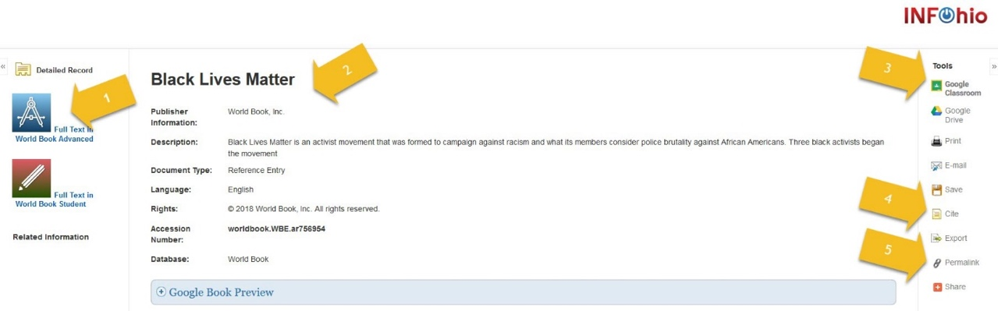
- Label the main components of the EBSCO Detailed Record page.

1. ________________________________ 2. ________________________________
3. ________________________________ 4. ________________________________
5. ________________________________

- Fill in the blanks in the statement below.
If you want to save a link to an item you find in ISearch, you must use the _________. Do not use the URL you see in your browser address bar. Instead, click the _________ button. A box just above the item details information will appear that includes a URL you can use to get back to that item.

- If you are looking for texts with information on GMOs, why should you also try a search for “genetically modified organisms”?

Getting the Results You Want
- The more limiters you apply, the results you'll get, but your results will be more .
- The limiters are to each tab. In other words, applying a limiter on the My Library tab on the Encyclopedias tab. As you visit each new tab, you will be with the results from your search.
- When you apply a limiter, you are telling ISearch that you only want to see those results from your search that .
- You can click a to narrow your results to items from a single publication.

