Fetch Checklist and Guided Notes

Use this Guide for the following lessons in the Fetch Training Class:
- Getting to Know Fetch
- Finding Fetch on the INFOhio Website
- Searching with Fetch
- Fetch Customizations
- Linking to Fetch
- Using the Fetch Widget
- Fetch Use Data
- Teaching Students to Use Fetch
- Linking to ISearch

Fill in the blanks in the text below using words from the training site.

Getting to Know Fetch
Fetch uses a ________________ interface, includes a _______________ search and a reading-level search.

Label the main components of the Fetch landing page:

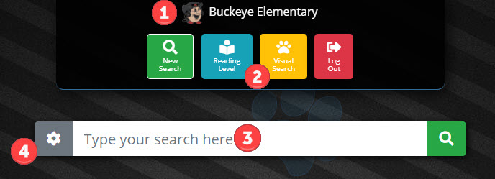

1. ________________________________ 2. ________________________________
3. ________________________________ 4. ________________________________

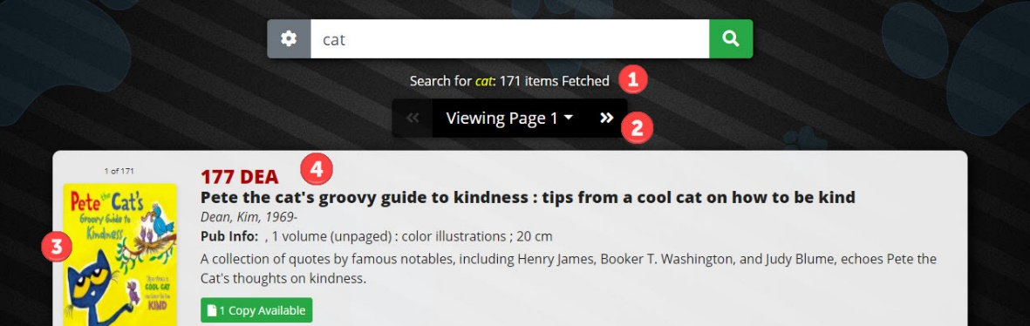

Label the main components of the Fetch results screen.

1. ________________________________ 2. ________________________________
3. ________________________________ 4. ________________________________

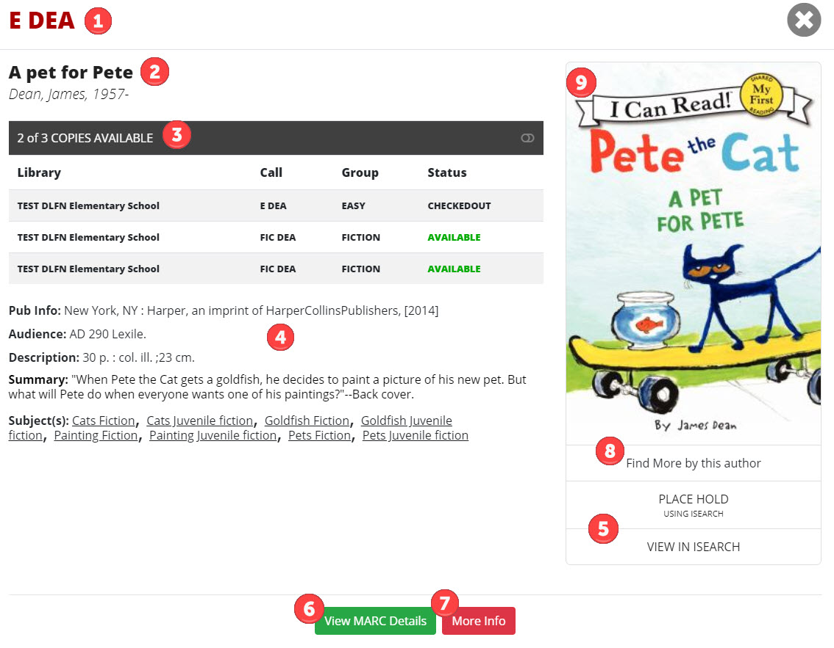
Label the main components of the Fetch Item Details screen.

1. ________________________________ 2. ________________________________
3. ________________________________ 4. ________________________________
5. ________________________________ 6. ________________________________
7. ________________________________ 8. ________________________________
9. ________________________________

Fetch searches your school library catalog _______________. If a student needs access to research resources like World Book or Ebsco, it is best if you start your search from _______________.

Finding Fetch
There are multiple ways to find Fetch, but you must be logged into the __________________________ with a school ________________ and _______________ and also use INFOhio's Library Services Platform to be able to access and search Fetch.

List two ways to link to Fetch:
1. ________________________________ 2. ________________________________

Using the following formula, build your Fetch URL and verify that it works.
https://fetch.infohio.org/itc/instance/library

______________________________________________________________________

Searching with Fetch
_______________ search can be helpful for pre-readers and beginning readers due to its _______________ interface.

More than _______________ of INFOhio catalog searches are _______________ searches.

List the three advanced search options available in Fetch:
1. ________________________________2. ________________________________
3. ________________________________

_______________ _______________, _______________, and Reading Counts are all reading programs that can be searched for in Fetch.

Within Fetch's simple search, you can use some more advanced search strategies using the boolean operators of _______________, _______________, and _______________.

Fetch Customizations

List the options for customizing Fetch:

1. ________________________________2. ________________________________
3. ________________________________4. ________________________________
5. ________________________________6. ________________________________
7. ________________________________

To request customizations, contact your ________________ at your ITC.

Linking to Fetch

Adding a _______________ will allow your students to get immediate results without having to stop on a landing page.

A Fetch _______________ is a hyperlinked image on a website.

To link to Fetch, or to create a Fetch _______________, you'll need to know your school library's unique Fetch ________________.

Using the Fetch Widget

To create the ______________ for your Fetch widget, use INFOhio’s Fetch widget generator.

Find the OPAC widget generator at ______________________________________________.

Fetch Use Data

To find _______________ for Fetch use, visit the INFOhio Resource Use Data page.

Teaching Students to Use Fetch

Students in grades K-2 are just learning how to _______________ for items in the library. Much of what will be taught to this age group will be the _______________ of how to access their library catalog.

Students in grades _______________ may benefit from a fundamentals review and benefit from learning some of the more _______________ features of Fetch.

One way to help students fail _______________ and develop grit is to provide them with opportunities in safe spaces to make, identify, correct, and learn from _______________.

Linking to ISearch

For those students ready to _______________ to ISearch from Fetch, it may be helpful to introduce them to _______________ with Fetch's ISearch features, before presenting them with all of ISearch itself. Two features that will help students to become more familiar with ISearch are ______________________________ and the Placing Holds in ISearch options.

