Hi! I’m Fetch – INFOhio's online catalog just for students! Let me help you find things in your library!

First, find your school using the Find My Library page on the INFOhio website.
Then, click on the paw print!

Basic Search

Type the topic you are looking for in the box. Hit Enter or click the magnifying glass.
To find the advanced search options, click the gear.

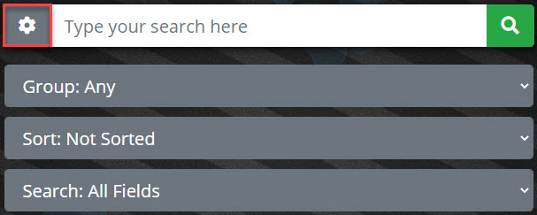
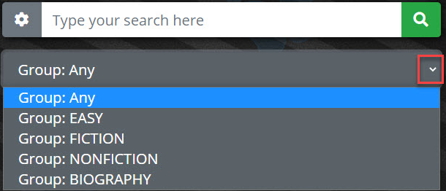
Group will help you find:

- True books – choose Nonfiction or Biography.
- Storybooks – pick Easy or Fiction.
- Any will give you a list of all books, both true and storybooks.

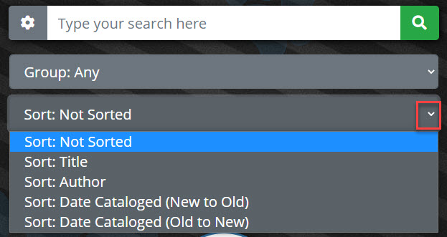
Sort options will put the titles in

- alphabetical order (ABC) by Title.
- alphabetical order (ABC) by Author’s name.
- put the newest items in your library at the top of the list (New to Old).
- put the oldest items in your library at the top of the list (Old to New).
- Or not sort them at all!

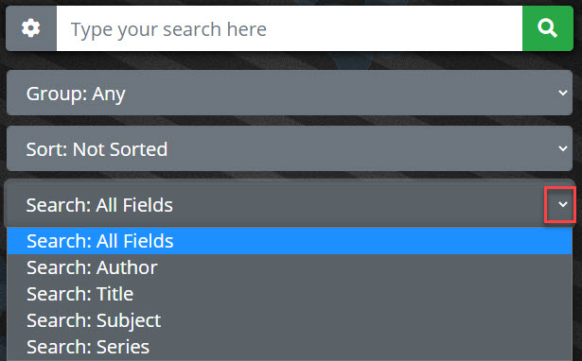
Search options allow you to search by certain fields:

- All Fields - Not sure which search option to choose? Use this!
- Author - Type the Author’s name.
- Title – Just one or two words will do!
- Subject - Find books about things.
- Series – Type the name of a series to get a list of titles from that series that are in your library.

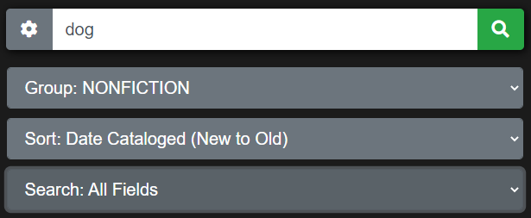

Let’s search for “dog” using the Nonfiction group, New to Old item sort, and an All Fields search.

Page layout created and text abridged by INFOhio from SirsiDynix
documentation. Copyright © 2021, SirsiDynix. All Rights Reserved
INFOhio is Optimized by the Management Council

This is what you see next.

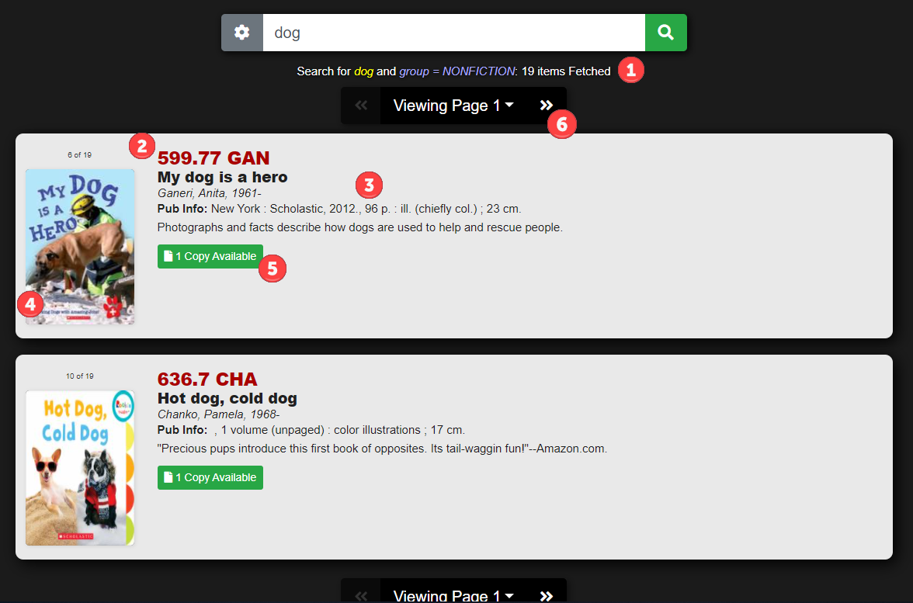

I tell you:
- how many items match your search.
- where you can find the item in your library. (E = Easy/Everybody section; B = Biography; F =Fiction)
- more information about the item or book. The titles are in black. If you click on the title, you will get the full record.
- what the cover of the book looks like. If the cover isn’t available, a book will show up.
- if you can check the item out. (Copy Available or No Copies Available)
- how many pages of results you can flip through.

Other Buttons:
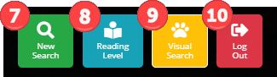

- New Search – Allows you to do another search or get Fetch ready for the next person.
- Reading Level – Search for Reading Counts, Lexile, or Accelerated Reader books.
- Visual Search - Use pictures to find books in the library.
- Log Out - Takes you back to the library welcome page.

To learn more about a book, click the title to open the full record.

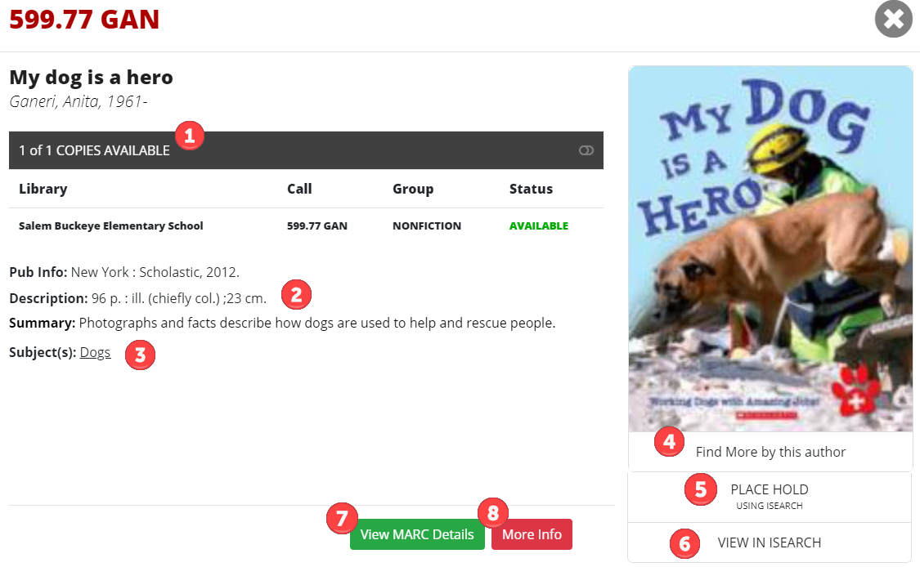
This is what you will see next. Some of these features, like holds, may not be available. That’s okay! Just let your librarian know what item you are looking for and they will help!

- Number of Copies and if it is available to check out.
- Book information. Read the summary to see if you’d like to read this book!
- Subjects – Click a subject to be linked to other titles that are similar.
- Find More by this Author will link you to other titles this author has written.
- Place Hold – If holds are turned on for your library, you can click this to go to ISearch to place a hold for this item. Don’t see Place Hold? That’s okay, just let your librarian know you’d like to read this book.
- View in ISearch – Clicking this will take you to ISearch. Don’t see this option? That’s okay!
- View MARC details – Librarians love this one!
- More Info – Click to go to a website with more information about the book and author.

Need help with spelling?
If you spell a word wrong…

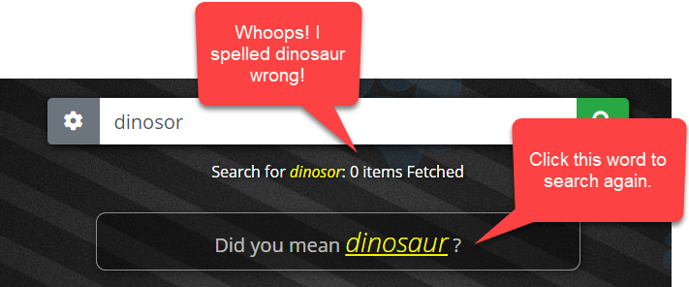

A list will appear with the new results.
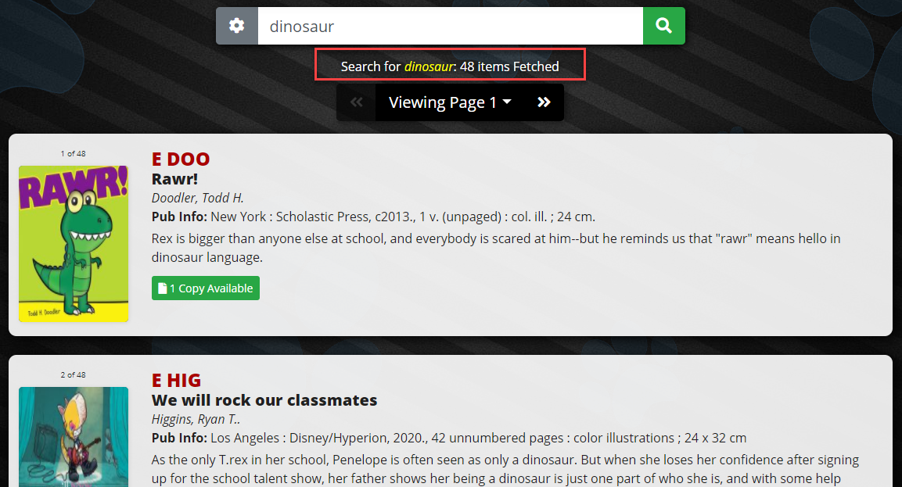

You can also try this…

Type the first few letters of the word and then a dollar sign $. (Hold the shift key and type the number 4 at the top of the keyboard to make a $.) You could try this for dinosaur.

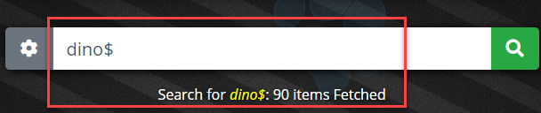

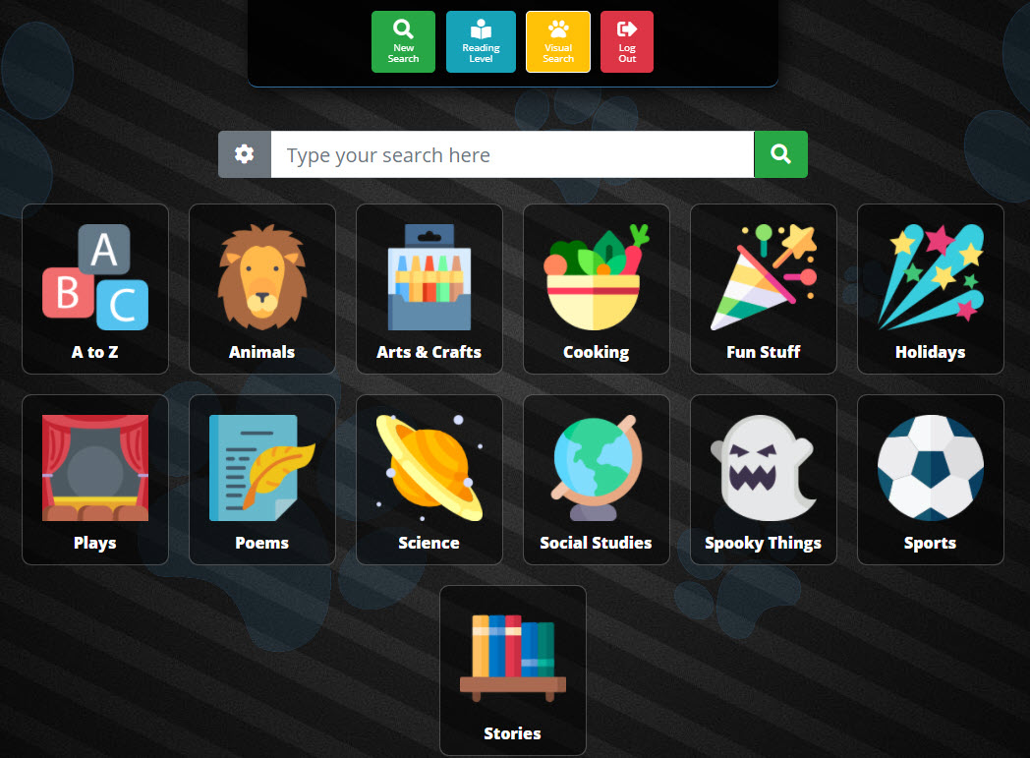

Visual Search

- Click on Visual Search.
- Choose a topic. I chose Animals.
- Narrow the topic. I chose Chickens.
- See the books in your library!
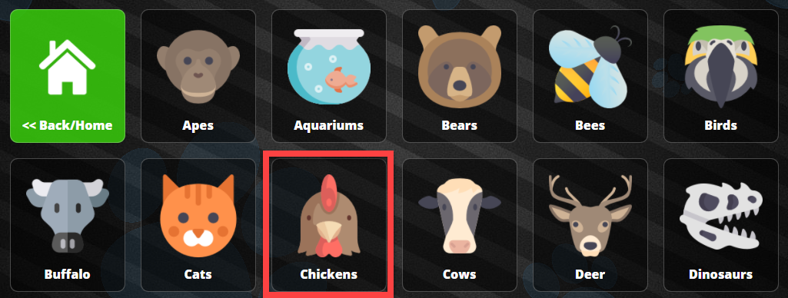
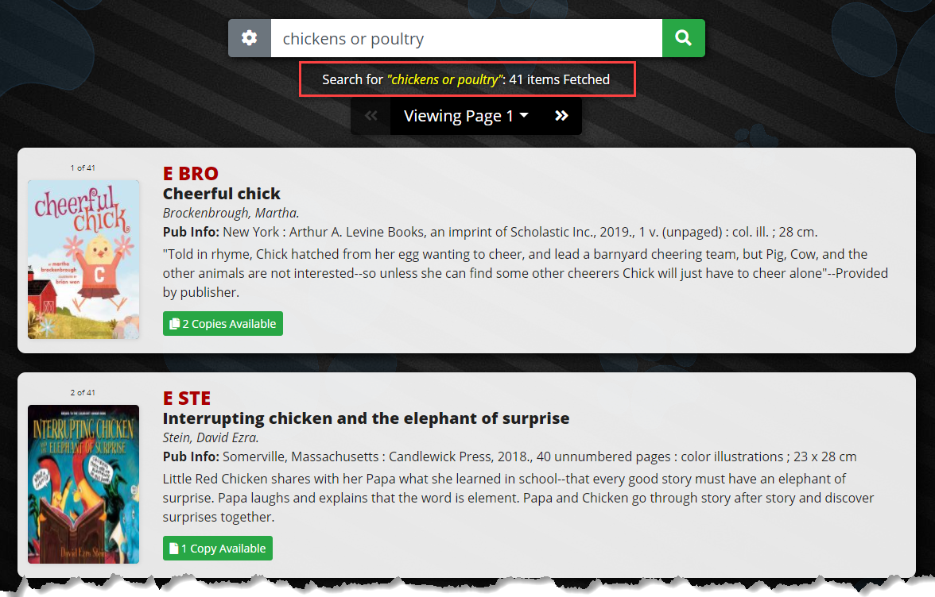
If you choose the A to Z box, you can pick a letter!
- Click on the A to Z box.
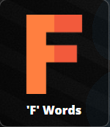
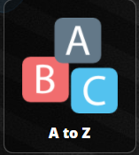
- Click on a letter. I like F, for Fetch!

- Now you can click on a picture that begins with F to see the books about it. I love fairy tales!
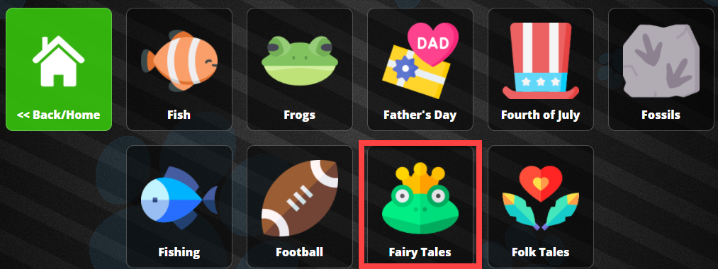
Now I can pick out a fairy tale book!
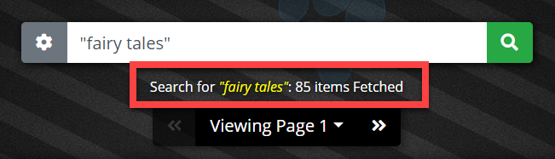

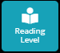
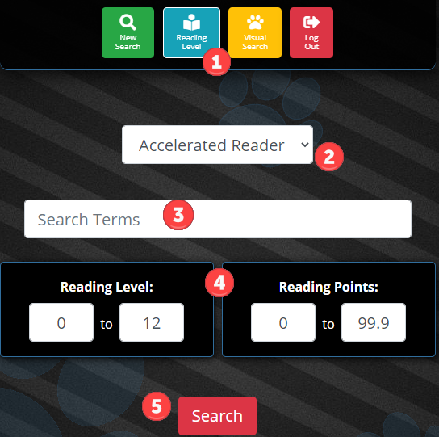
Reading Level Search
You can search by Accelerated Reader (AR), Lexile, and Reading Counts levels.

- Click the Reading Level button.
- Use the drop-down arrow to pick Accelerated Reader, Lexile, or Reading Counts.
- Enter a search term if you want to search for a specific topic. Otherwise, leave it blank and Fetch will search everything in the library collection.
- Use the box to enter your reading level and the number of points you want.
- If searching by Lexile, enter a score range from 0 to 1800.
- Click Search.

The results of the search will appear. Reading level information for the matching items will show under the item information.

