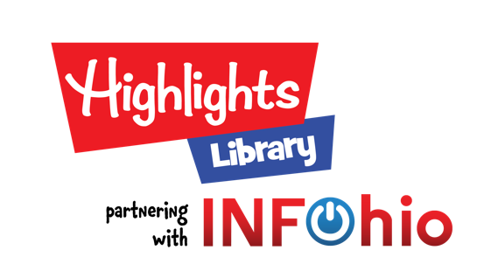

Dear Parent,
I am pleased to share with you some great news! INFOhio, Ohio’s PreK-12 Digital Library, has partnered with Ohio-based company, Highlights for Children. This means we now have access to thousands more quality eBooks. Highlights Library is dedicated to promoting a love of reading while focusing on the whole child and their social-emotional well-being through their digital resource called Highlights Library.
Through this program, your child can use Highlights Library, a comprehensive digital reading platform with over 2,500 leveled Highlights eBooks. The Highlights Library is designed to motivate young learners, helping them become confident and capable readers.
3 Things your child will love about Highlights Library...
- Titles that reflect your child’s reading level and interests
- A diverse collection of stories that allows your child to see themselves and others in literature
- Read aloud features to support readers of all ages
2 Tips for getting started...
- Visit www.infohio.org and choose K-5 resources. Click Highlights Library.
- Read a book with your child and talk about what you read! Choose Rewards to play Hidden Pictures, a Highlights classic.
1 Thing to remember...
Encourage your child to read one book per day in Highlights Library. You may find that once they start reading, they won’t want to stop!
If you have any questions, feel free to contact me. For more digital learning resources your child will enjoy, visit www.infohio.org.
Sincerely,
[Teacher’s Name]

